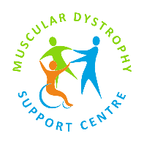
MDSC Clinical & Community Experience Pathway

Developing Future Professionals. Championing Inclusive Care.

Tier 5: MDSC Community Champion (Volunteer)

Purpose
To support the delivery of MDSC services and strengthen community engagement through non-clinical volunteering.

Key Activities
- Front-of-house support
- Welcoming and assisting service users
- Supporting events and fundraising
- Providing general administrative or community support

What Participants Will Gain
- Experience in a healthcare charity environment
- Improved communication and interpersonal skills
- Understanding of muscular dystrophy and community support
- Opportunity to contribute to meaningful work

Boundaries
- No clinical or therapeutic activity
- No handling of sensitive information without permission
- Must work within defined role

Supervision
- Line manager or designated staff contact
- Clear role expectations
- Ongoing support

Requirements
- Volunteer agreement
- Induction and training as required
- Adherence to MDSC values and policies

